**2.)** Using the linearized model from question one, the root locus plot below shows that the physical system will always be unstable in open-loop, because there will always be a pole in the right-half plane (RHP).



Figure A. Open-Loop Physical System is Always Unstable.

A lead controller adds a pole and a zero to the system, with the pole being greater in magnitude than the zero (i.e. further from the imaginary axis) and both in the left-half plane (LHP). Because there were no design requirements given (settling time, overshoot, etc.), specific values were not as critical as they may have been otherwise, and we chose our controller pole to be at -80 and the controller zero to be at -20. Additionally, to ensure the proper sign throughout the system, a factor of -1 was applied to the controller. The root locus plot below shows the result of applying the controller to the system. This plot shows that the system will be stable if the gain is large enough, because all of the closed-loop poles will be within the LHP. The gain magnitude must be greater than 0.096 for the rightmost pole to cross into the LHP, and greater gains reduce the settling time and steady-state error. But as the gain increases, the imaginary poles move further away from the real axis (lower damping). Therefore, we selected a gain of 0.37 as a compromise value. Our lead compensator is given by the equation below, and its effect on the physical system is shown in the following plot.



$$C\left(s\right)= -0.37\frac{(s+20)}{(s+80)}$$

Figure B. With Sufficient Gain, Lead Controller Stabilizes System.

**2.a)** From the root locus plot and Matlab sisotool analysis, the system must have a gain greater than 0.096 in magnitude (-20.35 dB). As mentioned previously, this gain must be negated to ensure the proper sign of the signal in the system. With the controller, *C(s)*, the closed-loop transfer function is given by:



$$\frac{2.367∙{10}^{4}s+4.732∙{10}^{5}}{s^{3}+79.995s^{2}+1.746∙{10}^{4}s-2.290∙{10}^{4}}$$

Figure C. Bode Plot of the Closed-Loop System.

From the closed-loop bode plot, the bandwidth (frequency at which the magnitude is -3 dB) is expected to be 468.22 rad/sec (74.52 Hz).

**2.b)** Figure G and H show the Simulink Models of the nonlinear and linearized models, respectively, with the controller applied. Figure J shows the Simulink model of the controller itself, which is the same for the linearized and nonlinear models. All other sub-systems in the model are the same as shown in part 1e.

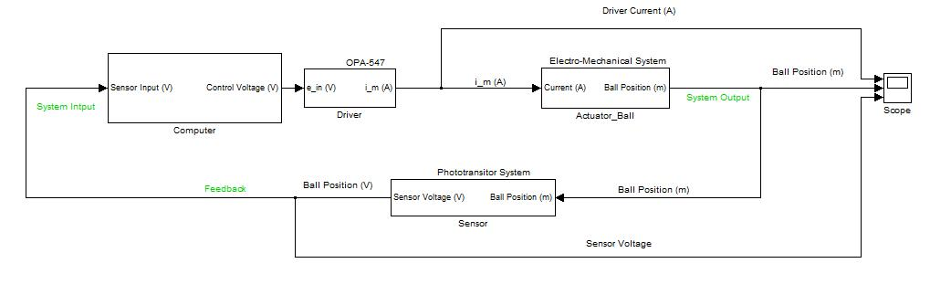

Figure G. Nonlinear Model with Controller.

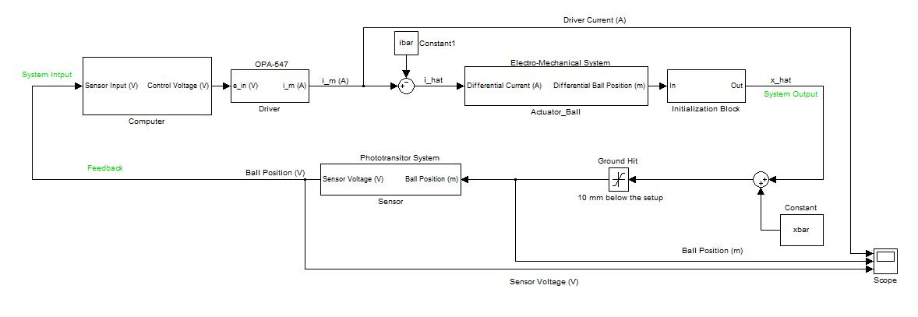

Figure H. Linearized Model with Controller

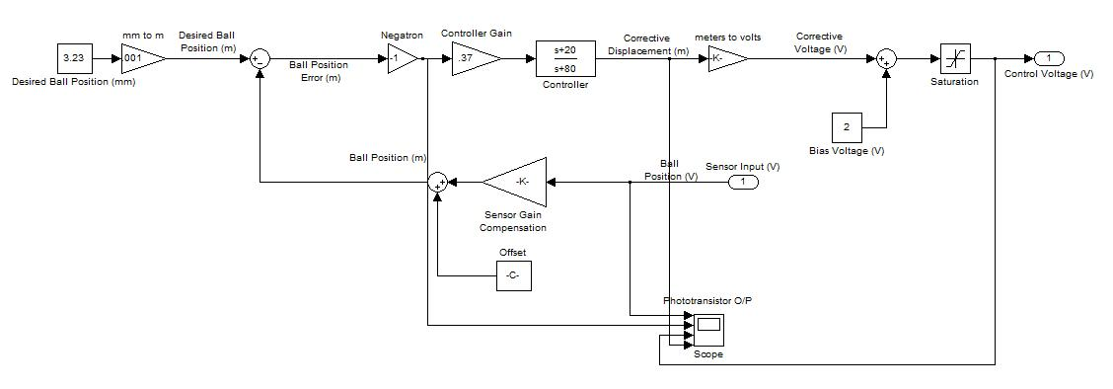

Figure J. Controller Applied to both Models.

Figure D shows the time response of both models when the ball is started at the nominal height ( $\overline{x}$ = .00323m). Unlike the uncontrolled systems which oscillated continuously, when the controller is applied both systems settle on a steady position levitated below the electromagnet (the nonlinear model has some initial oscillations before settling).



Figure D. With the Controller, Both Models Have Steady Levitation Positions When Starting at the Nominal Distance.

If the starting position of the ball is moved closer to the magnet, both systems remain stable until a position 0.8mm above the set point, when the linearized model becomes unstable. An example of this is shown in figure S. In contrast, when the starting position is moved away from the magnet both systems remain stable until a position 1.9mm below the set point, when the nonlinear model becomes unstable. An example of this is shown in figure K.



Figure S. When Starting 0.8mm Above the Set Point, the Linearized Model is Unstable and the Ball Falls Away.



Figure K. When Starting 1.9mm Above the Set Point, the Nonlinear Model is Unstable and the Ball Falls Away.